STAT 301 Group Project: ANOVA Analysis of Supply Chain Data
Introduction
This report analyzes a supply chain dataset from Kaggle (Amirmotefaker, n.d.) containing 100 product SKUs across three categories: cosmetics, haircare, and skincare. The original dataset had ambiguous column names (multiple "Lead time" columns and a "Costs" column). After reviewing the associated Kaggle notebook, four columns were renamed for clarity: Supplier_Lead_Time, Order_Lead_Time, manufacturing_lead_time, and Total_Costs. For this analysis, Shipping.costs refers exclusively to the carrier fee, distinct from Total_Costs.
Research Question 1: Does product type significantly affect manufacturing costs?
Variables: Product type (categorical, 3 levels) → Manufacturing costs (numeric)
Hypotheses:
- $H_{0}$: $μ_{\text{cosmetics}}=μ_{\text{haircare}}=μ_{\text{skincare}}$
  - (Null: The mean manufacturing costs are equal for all three product types.)
- $H_{a}$: At least two of the population means are different.
  - (Alternative: The mean manufacturing cost differs for at least one product type compared to the others.)
Significance Level: $α=0.05$
Research Question 2: How do shipping carrier and location interact to affect shipping costs?
Variables: Shipping carrier (categorical, 3 levels), Location (categorical, 5 levels) → Shipping costs (numeric)
Hypotheses:
Main Effect of Shipping Carrier:
- $H_{0}$: $μ_{\text{Carrier A}}=μ_{\text{Carrier B}}=μ_{\text{Carrier C}}$
- $H_{a}$: At least two carriers have different mean shipping costs.
Main Effect of Location:
- $H_{0}$: $μ_{\text{Bangalore}}=μ_{\text{Chennai}}=μ_{\text{Delhi}}=μ_{\text{Kolkata}}=μ_{\text{Mumbai}}$
- $H_{a}$: At least two locations have different mean shipping costs.
Interaction Effect (Carrier × Location):
- $H_{0}$: There is no interaction between Shipping Carrier and Location.
- $H_{a}$: There is an interaction between Shipping Carrier and Location.
Test Used: Two-way Factorial ANOVA
Significance Level: $α=0.05$

Methods
Data Processing: The original dataset (100 rows, 24 columns) had no missing values or duplicates. Categorical variables were converted to factors. Outlier detection using the IQR method revealed no extreme outliers in key numeric variables. The cleaned dataset retains all 100 observations.
Statistical Analysis:
Q1: One-way ANOVA (one categorical IV with 3+ groups, one continuous DV)
Q2: Two-way ANOVA (two categorical IVs, testing main effects and interaction) The design was unbalanced (see Table 2), so Type II sums of squares were used via the Anova() function from the car package.
Handling of Unbalanced Design (Q2)
The two-way ANOVA design was assessed for balance. The marginal frequencies showed unequal sample sizes across carriers (Carrier A: 28, Carrier B: 43, Carrier C: 29) and across locations (Bangalore: 18, Chennai: 20, Delhi: 15, Kolkata: 25, Mumbai: 22). Table 2 shows the 15 carrier-location combination cell counts, which range from [min] to [max] observations. Because the design is unbalanced, Type II sums of squares were used for hypothesis testing via the Anova() function from the car package in R. Type II sums of squares are appropriate for unbalanced designs when testing main effects in the presence of a possible interaction.

Product Type | n | Mean (USD) | SD (USD) |  | Min | Max
Cosmetics | 26 | 44.23 | 28.15 |  | 1.90 | 99.47
Haircare | 34 | 49.63 | 29.87 |  | 11.44 | 97.73
Skincare | 40 | 50.17 | 28.92 |  | 1.09 | 97.83
Results

Table 1: Descriptive Statistics of Manufacturing Costs by Product Type

Figure 1: Mean Manufacturing Costs by Product Type with 95% Confidence Intervals

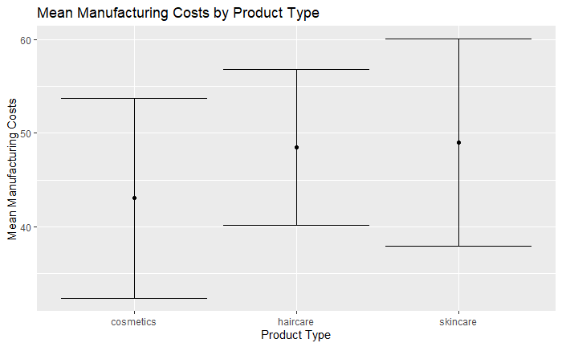
Figure 1 Caption: *Mean manufacturing costs with 95% confidence intervals for each product type. Error bars represent confidence intervals. No significant differences were found between groups (p = 0.692)

Q1: One-way ANOVA (Product Type vs. Manufacturing Costs)
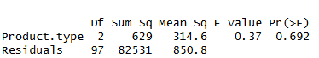
Tukey HSD post-hoc: All pairwise comparisons p > 0.69 (not significant)
Decision: Fail to reject H₀. There is insufficient evidence that product type affects manufacturing costs.

Q2: How do Shipping Carrier and Location interact to affect Shipping Costs?
Table 2: Sample Size per Carrier-Location Combination
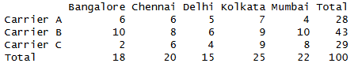
Note: The unequal cell counts confirm an unbalanced design. Type II sums of squares were used for all hypothesis tests.
Table 3: Type II Two-way ANOVA Results (Shipping Costs)
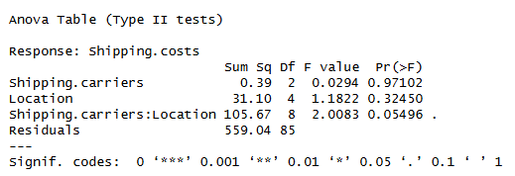
Figure 2: Interaction Plot – Shipping Carrier × Location
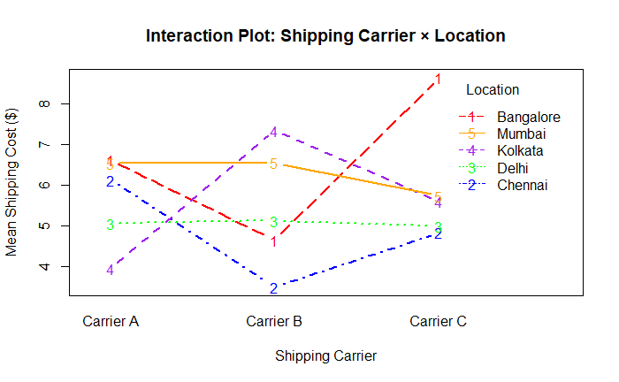
Main Effect (Carrier): Fail to reject $H_{0}$. There is no significant main effect of shipping carrier on shipping costs (p = 0.97).
Main Effect (Location): Fail to reject $H_{0}$. There is no significant main effect of location on shipping costs (p = 0.32).
Interaction Effect: Fail to reject $H_{0}$ at the strict 0.05 level. However, the p-value (0.055)> 0.05, there is insufficient evidence of a statistically significant interaction between shipping carrier and location.

Final Conclusion
Most Interesting Finding:
The borderline interaction between carrier and location (p = 0.055) is the most interesting finding. While not statistically significant at α = 0.05, this result suggests that shipping costs may depend on the combination of carrier and location rather than either factor alone. The interaction plot shows crossing lines, particularly for Carrier C across different locations. This trend warrants further investigation with a larger, balanced sample.
Limitations:
- Unbalanced design (key limitation): The two-way ANOVA has unequal sample sizes across the 15 carrier-location combinations. With only 100 total observations distributed unevenly, some cells have very small counts. This reduces statistical power and required the use of Type II (rather than Type I) sums of squares. A balanced design would provide more reliable results.
- Sample imbalance in Q1: Uneven group sizes (cosmetics n=26, haircare n=34, skincare n=40) may affect statistical power.
- Generalizability: Single supply chain dataset may not apply to other industries, regions, or time periods.
- Confounding variables: Defect rates, transportation modes, and order quantities were not included in the models.
Summary: This analysis found no statistically significant evidence that product type affects manufacturing costs (p = 0.692), nor that shipping carrier (p = 0.971) or location (p = 0.325) independently affect shipping costs. A borderline interaction between carrier and location (p = 0.055) suggests a potential combined effect that merits future study with larger, balanced sample sizes. For supply chain managers, these findings imply that shipping cost differences—if they exist—may depend on the specific pairing of carrier and location rather than either factor alone.

References
Amirmotefaker. (n.d.). Supply chain analysis [Kaggle notebook]. Retrieved from https://www.kaggle.com/code/amirmotefaker/supply-chain-analysis/input

Appendix: Key Outputs
One-way ANOVA Summary:

Two-way ANOVA Summary:
